# CS 255 System Design Document Template

## UML Diagrams

### UML Use Case Diagram

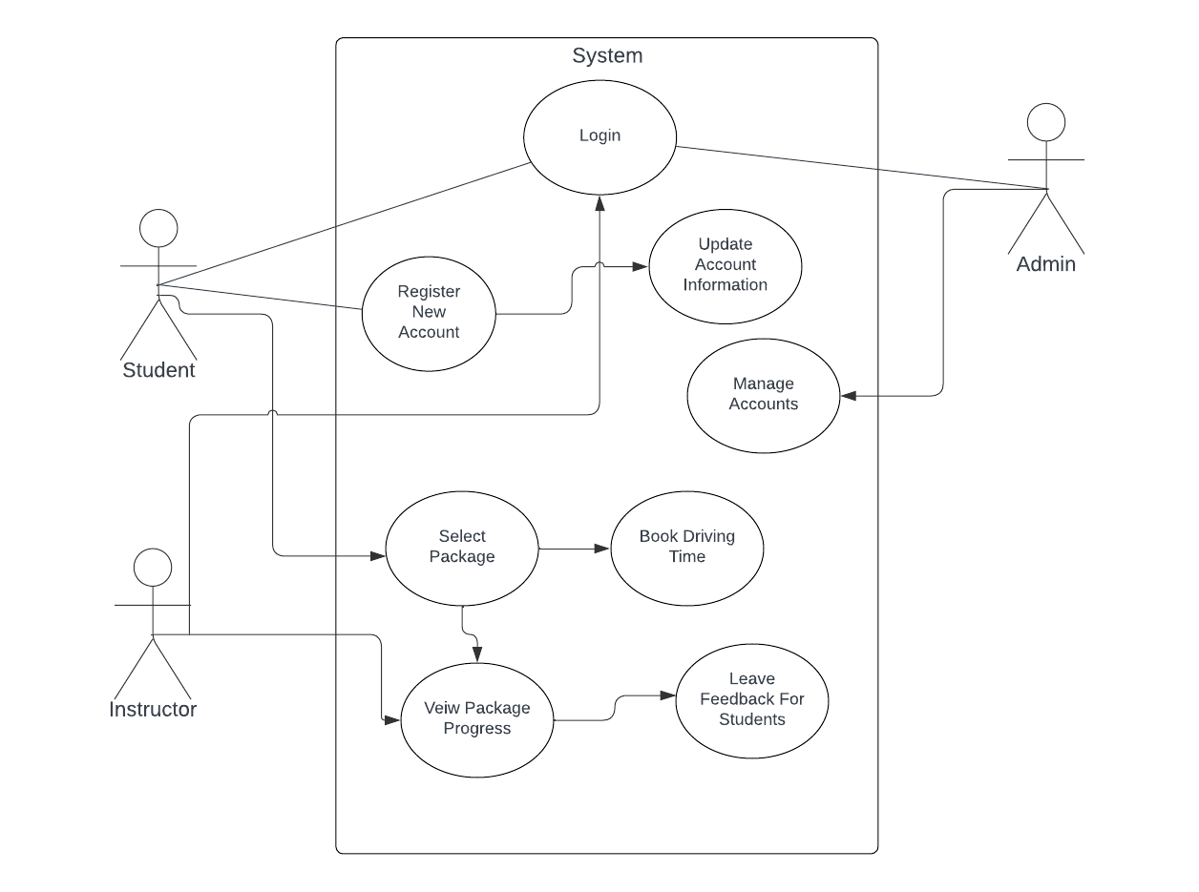

### UML Activity Diagrams

### 

### UML Sequence Diagram

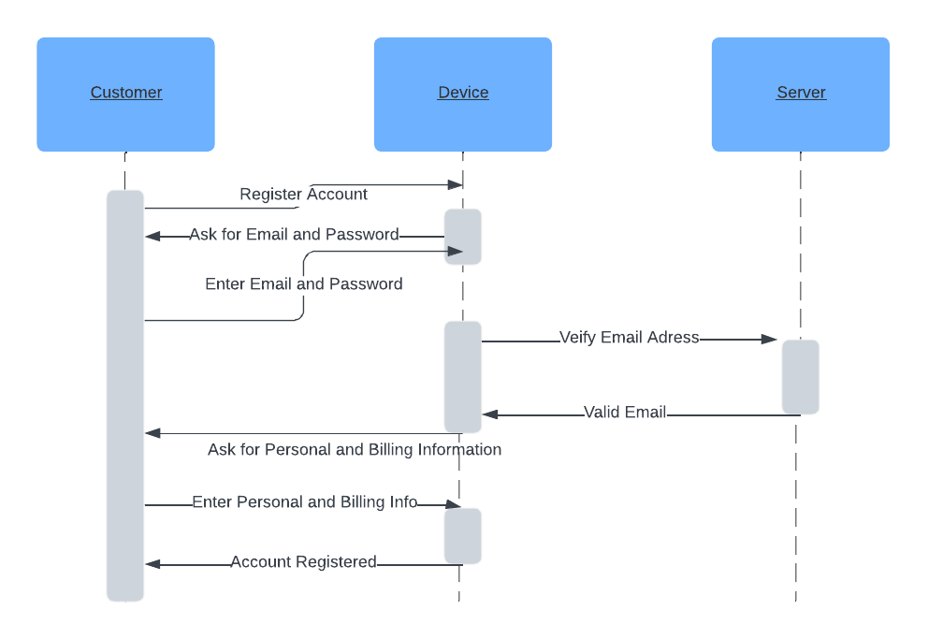

### UML Class Diagram

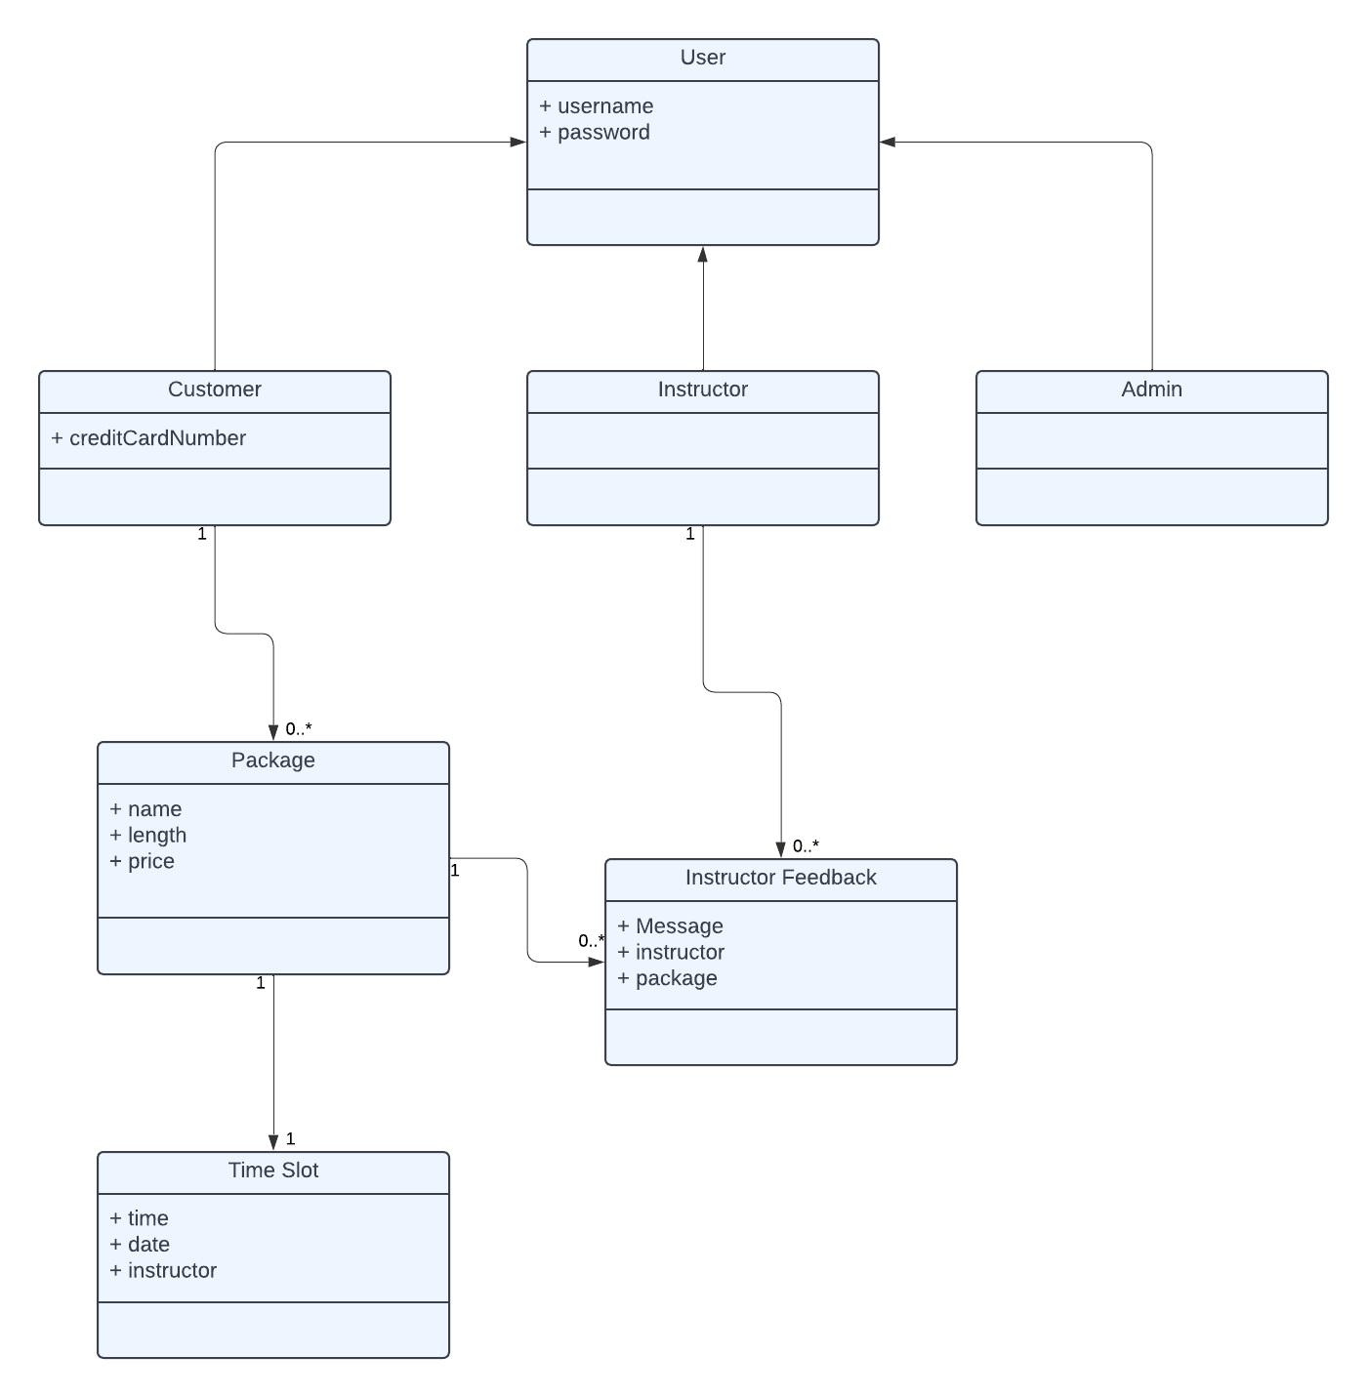

## Technical Requirements

*Some of the technical requirements needed for driver pass are as follows:*

* *Web server for hosting web application and databases*
* *Operating Systems like Linux or Windows Server to host the application*
* *RDBMS like MySQL*
* *Web framework like Django or NodeJS to build the various services*
* *Unit testing frameworks like JUnit*
* *Version control system like Git for source code management*
* *IaaS Cloud platform like AWS or Azure*